Prerequisite
Good knowledge and understanding of the concepts of C programming language are necessary for learning the concepts of Computer graphics. Good understanding about basic mathematics allows us to better understand the concept of computer graphics.

Audience
This tutorial is helpful for the students who are interested in learning the use of graphics on the computer. The tutorial covers the basics of graphics and development of various visuals by the implementation of graphics in the computer.
#5. What is the difference between the following display devices (monitors)? How each device works?
Introduction
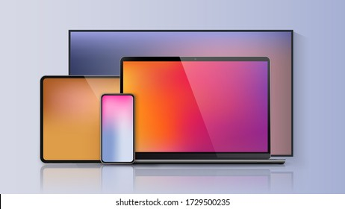
  - The display of a computer is responsible for graphic display
  - It can display text, picture and video
  - The primary output device in graphics system is a video monitor.
  - The operation of most video monitors is based on the standard Cathode-Ray Tube (CRT) design
- Cathode-ray Tube (CRT)
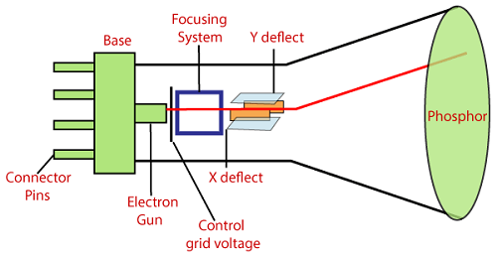
  - A CRT monitor displays color pictures by using a combination of phosphors that emit different colored light. Two basic methods are used for producing color displays (i) Beam penetration and (ii) shadow-mask method.

Beam-Penetration Method
- Two layers of phosphor, usually red and green are coated onto the screen.
- A beam of slow electrons excites only the outer red layer, fast electrons penetrates through inner red layer and excites the inner green layer. The electrons with intermediate speed produce the combinations of red and green color.
- The speed of electrons is controlled by the beam-acceleration voltage. But the quality of the pictures is not good here.

Shadow-Mask Method
- It can produce a much wider range of color than the beam-penetration method. A shadow-mask CRT has three phosphor color dots at each pixel position with red, green and blue.
- The color CRT has three color-phosphor dots (dot triad) – red, green and blue – at each point on the screen surface
- This type of CRT has three electron guns, one for each color.
- The three electron beams are deflected and focused as a group onto the shadow mask, which contains corresponding holes for each pixel position.
- The color variation is obtained by varying the intensity levels of the three electron beams. For example, turning off the green and red beam, we will get only blue color.
- A shadow mask – a fine metal sheet with a regular array of holes punched in it – is aligned in a way that the set of three beams sweeps across the shadow mask converges and intersects at the holes and then hits the correct phosphor dot as shown in Figure 1.2

Figure 1.2 Electron beams passing Shadow Mask
  - To produce picture on screen, these electron beams start at the top of the screen and scan rapidly from left to right along the rows of electron dots
  - They return to the leftmost position one line down and scan again and repeat this to cover the entire screen

B. Liquid crystal display (LCD)
Introduction
- Commonly used in small systems, such as calculators, and portable, laptop computers.
- These non-emissive devices produce a picture by passing polarized light from the surroundings or from an internal light source through a liquid-crystal material that can be aligned either block or transmit the light
- LCD basically consists of a layer of liquid crystal, sandwiched between two polarizing plates
- The polarizers are aligned perpendicular to each other (one vertical and the other horizontal), so that the light incident on the first polarizer will be blocked by the second
- LCD displays are addressed in a matrix fashion. Rows of matrix are defined by a thin layer or horizontal transparent conductors, while columns are defined by another thin layer of vertical transparent conductors; the layers are placed between the LCD layer and the respective polarizer plate
- The intersection of the two conductors defines a pixel position
- The liquid crystal material is made up of a long rod-shaped crystalline molecules
- The individual polar molecules in nematic (spiral) LC layer are normally arranged in a spiral fashion such that the direction of polarization of polarized light passing through it is rotated 90 degrees
- Light from an internal source enter the first polarizer (say horizontal) and is polarized accordingly (horizontally). As light passes through the LC layer is twisted 90 degrees (to align with the vertical) so that it is allowed to pass through the rear polarizer (vertical) and reflect from the reflector behind the rear polarizer. The reflected light when reaches the viewers travelling in reverse direction, the LCD appears bright
- In color LCD there are layers of three liquid crystal panels on top of another, each filled with a colored (red, green or blue) liquid crystal
Advantages | Disadvantages:
- Produce a bright image  - Energy efficient  - Completely flat screen | - Fixed aspect ratio & Resolution  - Lower Contrast  - More Expensive

  - Light Emitting Diode (LED):
Introduction
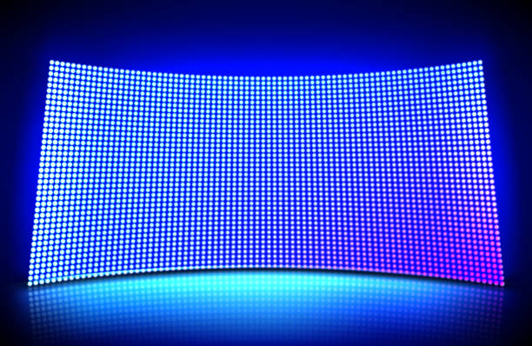
- LED is a device which emits when current passes through it. It is a semiconductor device.
- The size of the LED is small, so we can easily make any display unit by arranging a large number of LEDs.
- LED consumes more power compared to LCD. LED is used on TV, smartphones, motor vehicles, traffic light, etc.
- LEDs are powerful in structure, so they are capable of withstanding mechanical pressure. LED also works at high temperatures.
Advantages | Disadvantages
- The Intensity of light can be controlled.  - Low operational Voltage.  - Capable of handling the high temperature. | - More Power Consuming than LCD.

d. PLASMA
Introduction
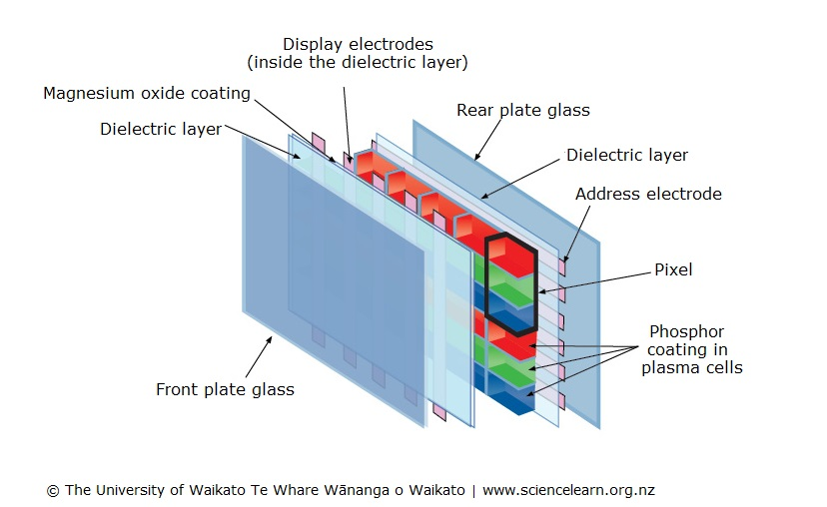
- Here a layer of gas (usually Neon) is sandwiched between two glass plates
- Thin vertical (column) strips of conductor run across one plate, while horizontal (row) conductors run up and down the plate
- By applying high voltage to a pair of horizontal and vertical conductors, a small section of gas at the intersection of the conductors breaks down into glowing plasma of electrons and ions
- Thus, in the array of gas bulbs, each one can be set to an ‘on’ (glowing) state or ‘off’ state by adjusting voltages in the approximate pair of conductors
- Once set ‘on’ the bulbs remain in that state until explicitly made ‘off’ by momentarily reducing the voltage applied to the pair of conductors. Hence no refreshing is necessary
- Because of its excellent brightness, contrast and scalability to larger sizes, plasma panel is attractive

Components of Plasma display
- Anode: It is used to deliver a positive voltage. It also has the line wires.
- Cathode: It is used to provide negative voltage to gas cells. It also has fine wires.
- Gas Plates: These plates work as capacitors. When we pass the voltage, the cell lights regularly.
- Fluorescent cells: It contains small pockets of gas liquids when the voltage is passed to this neon gas. It emits light.
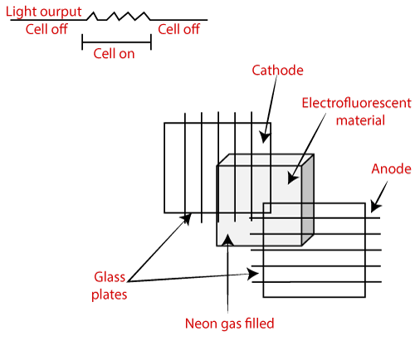
Advantages: | Disadvantages:
- Wall Mounted  - Slim  - Wider angle | - Phosphorus loses luminosity over time.  - It consumes more electricity than LCD.  - Large Size

#6Flat-panel display could be classified as emissive and non-emissive. Discuss the difference between the two and give examples for each.
Introduction
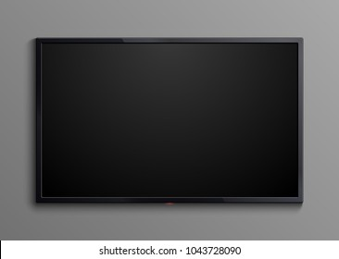
- It refers to a class or video devices that have reduced volume, weight and power requirements composed to CRT.
- To satisfy the need for a compact portable monitor, modern technology has gifted us LCD panel, plasma panel, LED (Light Emitting Diode) panel and thin CRT
- A main advantage of flat-panel displays is that they are thinner than CRTs and we can hang them on walls or wear on our wrists.
- The two categories of flat-panel displays are :
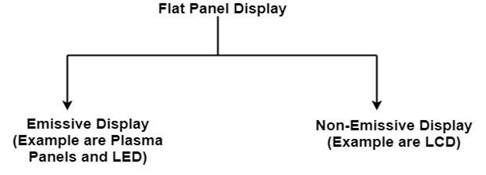
- Emissive displays:
- the device which convert electrical energy into light. (Plasma panel)
- Non-Emissive displays:
- used optical effects to convert sunlight or light from some other source into graphic patterns. (LCD)
- These devices are smaller, lighter and specifically thinner than the conventional CRT and thus termed as Flat Panel Display (FPD)
- FPDs in general and LCD panels in particular are most suitable for laptop computers but are expensive to produce
- Thin CRT is produced by bending the tube of normal CRT in the middle
#7. Discuss about the RGB color model and the YIQ color model
Introduction
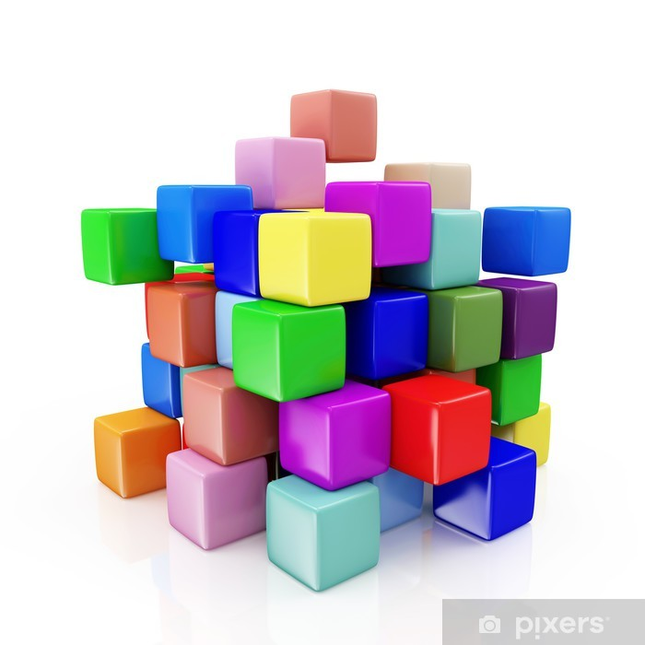
- A color model is an orderly system for creating a whole range of colors from a small set of primary colors.
- "Color model is a 3D color coordinate system to produce all range of color through the primary color set." There are millions of colors used in computer graphics. The light displays the color. A Color model is a hierarchical system in which we can create every color by using RGB (Red, Green, Blue) and CMYK (Cyan, Magenta, Yellow, Black) models. We can use different colors for various purposes.
- The total number of colors displayed by the monitor depends on the storage capacity of the video controller card.
- The Video controller card is used as an interface between the computer system and the display device. It is also known as “Video Random Access Memory (VRAM).”
Types of Color Models

- RGB color model
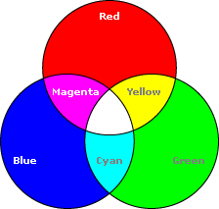
- It is also named as “Additive model.” RGB stands for Red, Green, Blue. The Additive color model uses a mixture of light to display colors. The perceived color depends on the transmission of light. It is used in digital media.
- For Example- Computer Monitor, Television etc.
- YIQ Color Model
- YIQ is the most widely colour model used in Television broadcasting. Y stands for luminance part and IQ stands for chrominance part.
- In the black and white television, only the luminance part (Y) was broadcast. The y value is similar to the grayscale part. The colour information is represented by the IQ part.
- There exist a formula to convert RGB into YIQ and vice-versa.

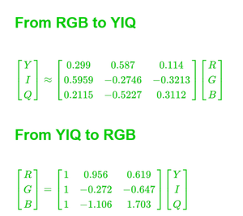
- YIQ model is used in the conversion of grayscale images to RGB colour images.
#8. How images are represented and processed inside the computer
Introduction
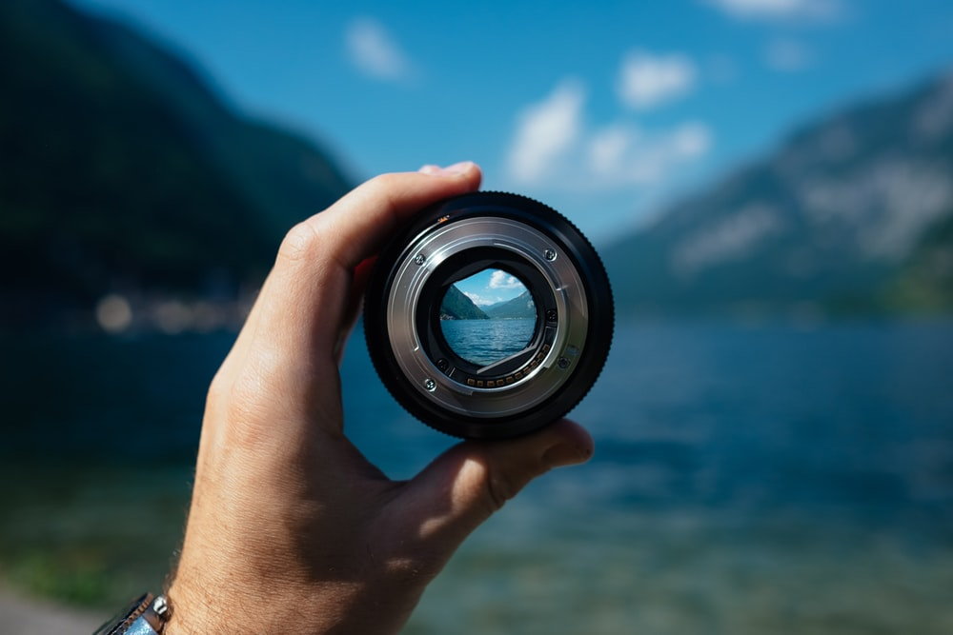
- What is an image?

An image consists of a rectangular array of dots called pixels. The size of the image is specified in terms of width X height, in numbers of the pixels.
Pixel.
- Pixel (also known as picture element) is the smallest size object or color spot that can be displayed and addressed on a monitor
- Image displayed on the monitor is made up of thousands of pixels
- Each pixel has particular color and brightness value
- The finer the pixels the more number of pixels displayable on a monitor- screen
Resolution
- The maximum number of points (pikel’s) that can be displayed without overlap on a screen is referred to as resolution
- Image resolution refers to the pixel spacing, i.e., the distance from one pixel to the next pixel
- A typical PC monitor displays screen images with a resolution somewhere between 25 pixels per inch and 80 pixels per inch (ppi)
- A full screen image with resolution 800 × 600 means that there are 800 columns of pixels, each column comprising 600 pixels, i.e., a total of 800 × 600 = 480000 pixels in the image area
Aspect Ratio
- The aspect ratio of an image is the ratio of the number of X pixels to the number of Y pixels
- The standard aspect ratio for PCs is 4:3 and some resolutions even use a ratio of 5:4
- Image displayed using 5:4 aspect ratio will cause the image to appear somewhat distorted
- The table below (Table 1.1) shows common resolutions, respective number of pixels and standard aspect ratios
Image Representation:
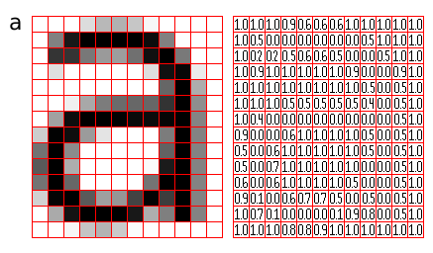
In computer science, we can represent an image in various forms. Most of the time, it refers to the way that brings information, such as color is coded digitally, and how the image is stored, i.e., how an image file is structured.
Several open standards were recommended to create, manipulate, store, and exchange digital images. The rules described the format of image files, the algorithms of image encoding, the form of additional information often named as metadata.
A digital image is the composition of individual pixels or picture elements. The pixels are arranged in the form of row and column to form a picture area. The number of pixels in an image is a function of the size of the image and number of pixels per unit length (e.g., inch) in horizontal as well as vertical direction.
- Remember, everything on a computer is stored as 0s and 1s.
- Thus, we must interpret these numbers as different forms of data.
- One bit (binary digit) can be either a 0 or a 1.
  - Therefore, it can only represent two possibilities: hot or cold, black or white, on or off, etc…



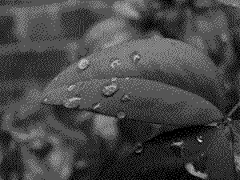
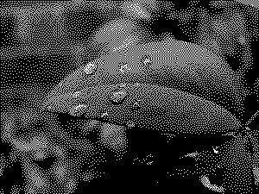
Bit Color Depth
24 bits

24 bits
8 bits
4 bits
2 bits
1 bit
00 01 10 11
Different shades of gray
24 bit TrueColor can represent more than 16.7 million unique colors. More colors than the human eye can distinguish!
1= ON 0 =OFF

Image Processing
Image processing is a method to perform some operations on an image, in order to get an enhanced image or to extract some useful information from it. It is a type of signal processing in which input is an image and output may be image or characteristics/features associated with that image. Nowadays, image processing is among rapidly growing technologies. It forms core research area within engineering and computer science disciplines too.
Image processing basically includes the following three steps:
- Importing the image via image acquisition tools;
- Analysing and manipulating the image;
- Output in which result can be altered image or report that is based on image analysis.
There are two types of methods used for image processing namely, analogue and digital image processing. Analogue image processing can be used for the hard copies like printouts and photographs. Image analysts use various fundamentals of interpretation while using these visual techniques. Digital image processing techniques help in manipulation of the digital images by using computers. The three general phases that all types of data have to undergo while using digital technique are pre-processing, enhancement, and display, information extraction.
#9. What is transformation in computer graphics? Discuss about the five common transformation
#10. What is homogeneous matrix? Discuss its use in transformation.
#11. Discuss about the following:
a. Animation b. Simulation
c. Image processing
d. Virtual reality
- Definition
virtual reality, which creates a totally artificial environment,
- Virtual Reality (VR) is fully immersive, which tricks your senses into thinking you’re in a different environment or world apart from the real world.
- Using a head-mounted display (HMD) or headset, you’ll experience a computer-generated world of imagery and sounds in which you can manipulate objects and move around using haptic controllers while tethered to a console or PC.
- It is also called a computer-simulated reality.
It refers to computer technologies using reality headsets to generate realistic sounds, images and other sensations that replicate a real environment or create an imaginary world.
- Example of Virtual reality (VR)
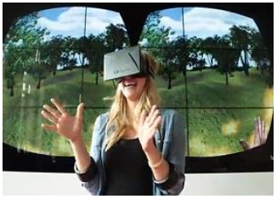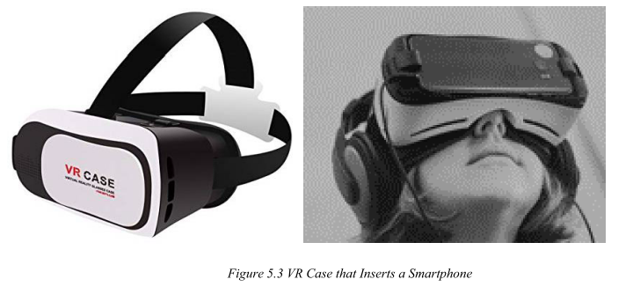
- Using VR devices such as HTC Vive, Oculus Rift or Google Cardboard, users can be transported into a number of real-world and imagined environments.

